IT2525/IT2130 Cyber Forensic Technologies & Process

AY2026 Semester 2

Practical 2 – Storage File Systems

Learning Outcome

After this practical lab, you will able to:

- Use AccessData FTK Imager to examine, locate and describe the evidence in the NTFS disk drive image file

Task 1 Examine and explain the file properties stored in a NTFS file system

Instructions

- Download a copy of the disk image file UnknownDrive.E01 into the Windows forensic virtual machine

- At AccessData FTK Imager top menu bar, click File -> Verify Drive/Image…

Question 1: Where does AccessData FTK Imager find the original hash of the drive image file for hash comparison?

Stored verification hash.

- Click to select UnknownDrive.E01 under Evidence Tree pane, then click top menu View -> Properties. The Properties of the drive image is shown under the “Evidence Tree” pane.

- Go to Properties ->Disk ->Drive Geometry.

Question 2: Calculate the total bytes available on this drive.
Answer: $512×12,685,680=6,495,068,160$

- Read the properties of the UnknownDisk.E01

Question 3: Who created this drive image file and when was it?

Answer: Stephen Bunting, 8/5/2007, 6:51:38am

- Click NTFS_Boot [NTFS], under Evidence Tree pane and read the File System Information of Partition 1.

Question 4: What is the cluster size (in bytes) in the NTFS file system?

Answer: 4096 bytes

- Question 5: How do you know that the file system in Partition 1 is NTFS without reading the Properties of the partition?

Answer: In the viewing pane, it states NTFS in the ASCII pane of the text.

- Under Evidence Pane, expand the subfolders under Partition 1 NTFS_Boot [NTFS]

- Click to select the root folder.

- After selecting the root folder, the File List Pane will display files in the root folder. Click to select the file $MFT (NTFS Master File Table). The file $MFT stores properties of every file and folder in the NTFS file system.

- You are asked to find the properties of the file with the name $LogFile in the NTFS file system.

- To do this, you can right click the space in the Viewer Pane of the file $MFT and click the Find from the menu.

- Type in LogFile to find the record in the file $MFT that contains the word LogFile. You should find the string LogFile in the line with the byte offset 08f0 (in hexadecimal number).

- Find the $DATA section marker 80 00 00 00 immediately after the file name LogFile.
See the marker 80 00 00 00 highlighted in blue colour below.

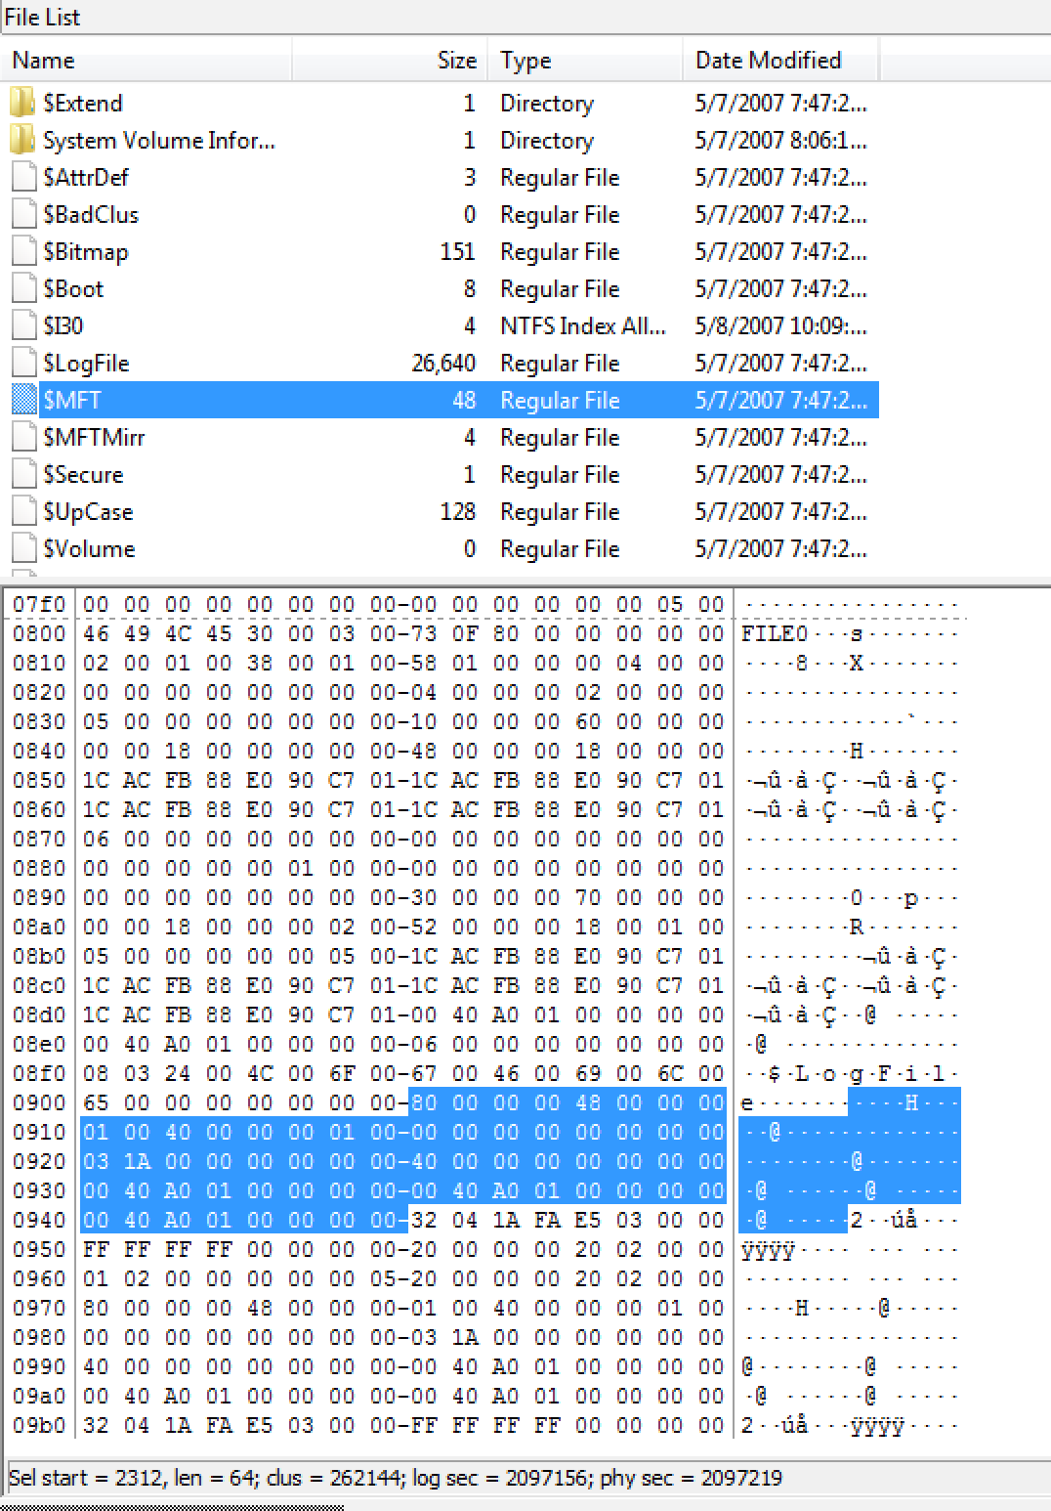

- Watch the video at https://www.youtube.com/watch?v=GHLwl77b36s to understand the step to find the data cluster runs information from the $DATA section marker 80 00 00 00. The data cluster runs information provides the number of the clusters in the run and the starting cluster address of the run.

- A file could use one or more data cluster runs to store its data.

- Identify 2 important properties of the file $LogFile :

- The size of the file (in clusters)
- The starting cluster number of the file

- Compare the size of the file $LogFile (in bytes) and the starting cluster number of the $LogFile file you get from the above steps with the values shown in Properties Pane of the file $LogFile below. The 2 sets of values should match.

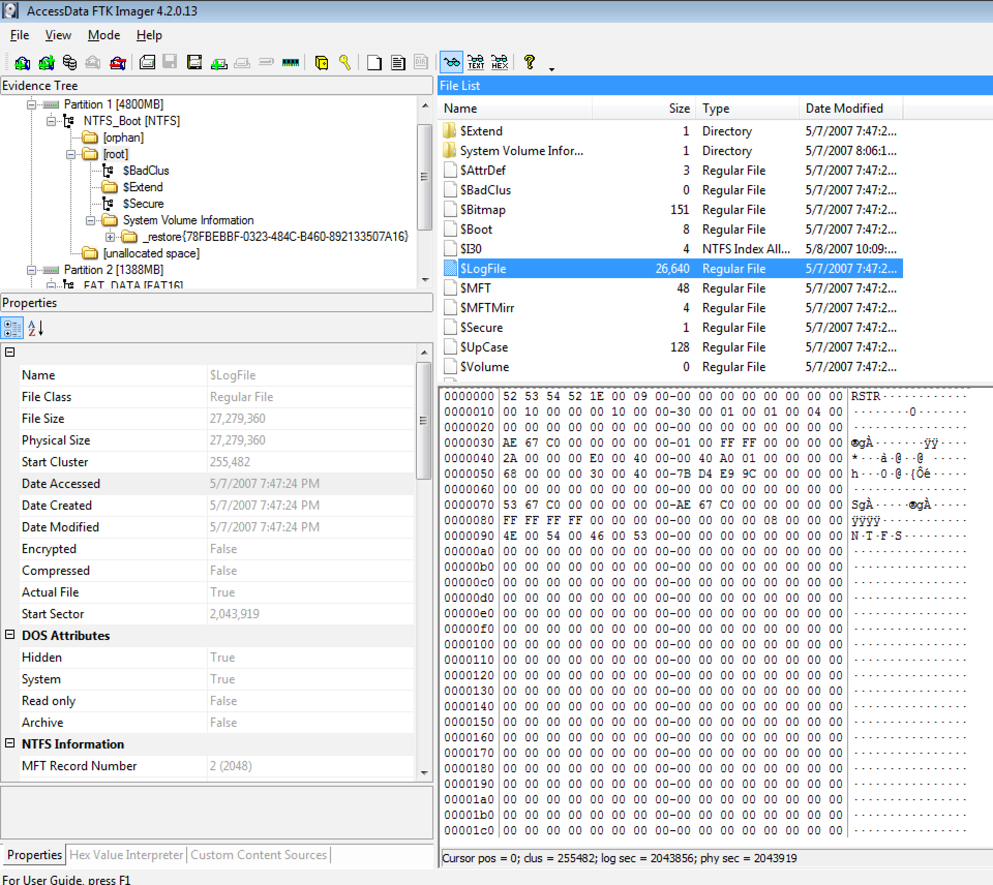

Question 6: Describe the steps to compare the 2 sets of values with relevant screenshots of
- the cluster size and starting cluster number in cluster data runs
- Start Cluster, Physical Size displayed in Properties Pane.

- Question 7: Complete and record the steps with relevant screenshots on the following tasks

- Locate the File Record of the file special_image.jpg.pgp in the $MFT file
- Locate the first cluster data runs
- Examine and determine the cluster size (in number of clusters) and starting cluster number for each cluster data runs used by the file special_image.jpg.pgp
Distinction Question:

- Load another evidence image DistinctionQn.E01,
using the above similar steps, can you extract the file SIT Highlight1-1.jpg from the hard disk cluster?

